Mobile power with no limits or compromises: Lorch takes TIG welding to the next level with the first high-frequency ignition Tig, powered from a battery.

Work with maximum power and flexibility: The mobile MicorTIG 200 electrifies TIG welders

The portable TIG welding inverter MicorTIG 200 engineered by Lorch Schweißtechnik has repeatedly demonstrated its impressive performance capabilities in the real world. Users of the new mobile TIG power package appreciate not only its incomparable versatility during industrial use and use at the construction site but also its intuitive control as well as its excellent ignition and welding characteristics.

The first TIG inverter capable of delivering high-frequency ignition while running from battery power offers TIG welders entirely new options both at the workshop and when on assignment on site or out in the field. “We are all raving about the MicorTIG. This machine finally gives us the freedom we need for our welding jobs”, declares Johannes Scheier, Managing Director and welder at Metallbau Johannes Scheier, summing up the benefits of the mobile welding unit, which the company uses at construction sites in combination with the battery pack. The All-In technology built into the welding inverter make it possible to connect the unit to the 115-230 Volt mains supply, a generator or the Lorch MobilePower battery pack. This versatility proves especially beneficial when used in remote locations as it eliminates the need to hunt for a mains connection which on-site can often mean waiting for an available outlet at the junction box.
The MicorTIG is the first machine of its kind that combines battery-powered welding with non-contact HF ignition. This helps preserve the tungsten electrode and puts an end to the risk of tungsten inclusion. “The ignition characteristics of the MicorTIG are nothing short of phenomenal”, analyses Daniel Schöttle, Managing Director at SMT Schöttle Metalltechnik GmbH, who imposes the strictest requirements on the precision and visual appearance of the weld seams. “The HF spark is very powerful and does not wonder.” Operating as a prototype construction company for the automotive industry, SMT has also been relying on the MicorTIG for welding high-alloy stainless steel such as chrome-nickel-molybdenum alloys and applauds its ability to provide for stable welding, even under the most challenging conditions.
Tipping the scales at a mere 6.8 kilogrammes, the mobile TIG inverter satisfies yet another requirement that is imperative in everyday use: minimum weight. “The MicorTIG is small, lightweight and handy”, confirms Volker Busch of Stadtwerke Riesa. “These properties check off all the boxes we are looking for in our field equipment as we often have to carry the welding machine up and down the stairs to reach different floors or basement rooms.” Better yet, its low weight does not diminish its suitability for heavy-duty use: Designed with special crash protection, the unit is guaranteed to survive falls from a height of up to 80 centimetres - clearly beating the standard requirement of 25 centimetres. This level of protection makes the machine the undisputed champion in its class.

To Johannes Scheier , the MicorTIG is not only ideal for applications on the go. It also possesses all the qualities of a full-blown industrial TIG system. A verdict that is corroborated by Stjepan Budic of F-Town Streetmachines: “The MicorTIG is undoubtedly an industrial welding machine through and through - delivering all the features every experienced TIG welder seeks.“ Another aspect the welders came to hold in high regard is the operating concept of the MicorTIG with its two variants BasicPlus and ControlPro.

Aside from the easy-to-learn BasicPlus control panel, users - who may have to adjust a large number of settings depending on their welding job and the material they are processing - also value the “ControlPro solution” with its graphic display, the detailed welding sequence control and the job memory function. Stjepan Budic: “The ControlPro control panel keeps you fully in charge of all parameters you can set and adjust. Finally, the repeatability ensured by the job memory helps save a tremendous amount of time.“ Another benefit: The ability to control the welding process remotely from the Lorch Powermaster torch eliminates the need to cover time-consuming distances between workpiece and machine. The welding current is displayed in an LED panel housed within the torch handle, while the current can be visualised and adjusted with ease, respectively, with the press of a button.

“Users working with the unit every day confirm: The MicorTIG 200 epitomises mobility in the area of TIG welding without trading off on performance”, says Lars Braun, Product Manager at Lorch Schweißtechnik GmbH, summing up the market début of the mobile inverter. “Professional features such as the non-contact HF ignition, the standard pulse function of up to 5 kilohertz for pulse welding on thin sheets, the easy-to-use graphical display or the job memory function deliver unheard of welding performance in a unit of such small and compact dimensions. Users working with the unit swear to the mobile inverter’s suitability for all types of TIG welding applications.”

Lorch Schweißtechnik GmbH is a leading manufacturer of electric arc welding systems for industrial applications, metalworking, partially automated solutions and robot automation systems. For more than 60 years, Lorch's premium quality systems have been manufactured in Germany at one of the world's most cutting-edge manufacturing plants for welding equipment and exported to more than 60 countries. The welding equipment engineered by Lorch merges first-rate suitability for real-world applications with superior ease of use and outstanding efficiency, setting new technological standards in the marketplace.

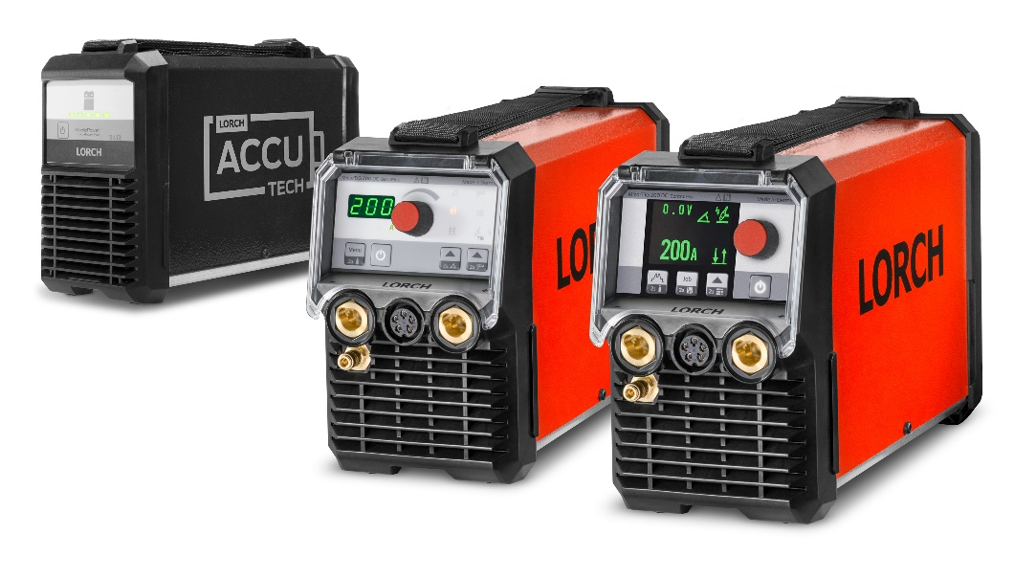Fig. 1: Whether running on 115-230 Volt mains, generator or battery power – its All-In technology and the operating variants “ControlPro” (right) and “BasicPlus” (centre) furnish the MicorTIG 200 by Lorch with everything any TIG welder can ask for in terms of flexibility and mobility.

Fig. 2: The convenient carrying handle and the fastening element make it a breeze to transport the MicorTIG 200 including the battery back from one place to the next.

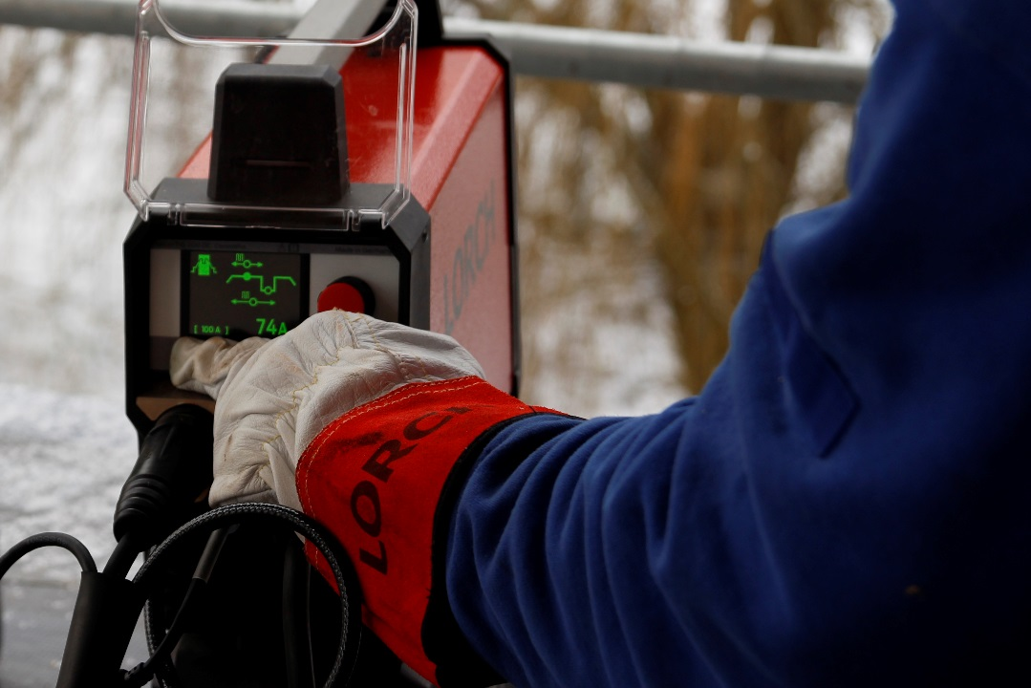

Fig. 3: Controlling the MicorTIG is completely intuitive and does not require any language skills thanks to the large graphical display with symbol-controlled operation.

For more information, log on to www.lorch.eu
PR contact:
Lorch Schweißtechnik GmbH
Lisa Michler
T +49 7191 503-0
F +49 7191 503-199
Im Anwänder 24-26
71549 Auenwald
Germany
Reprint free of charge. Specimen copy requested.

